**Reference No:** C14…..

**Damage Report Date:** .08/08/13...

**Incidents must be reported immediately.**

Damage found in Container must not to be touched until pictures have been taken to effectively demonstrate to stake holders how damage could have occurred?

In Container Container No.

In Warehouse How was it damaged? Forklift

Product

YAS101B S/N = Y691873TV

RXV475T S/N = (21)Y477713RT

*Insert* Picture:

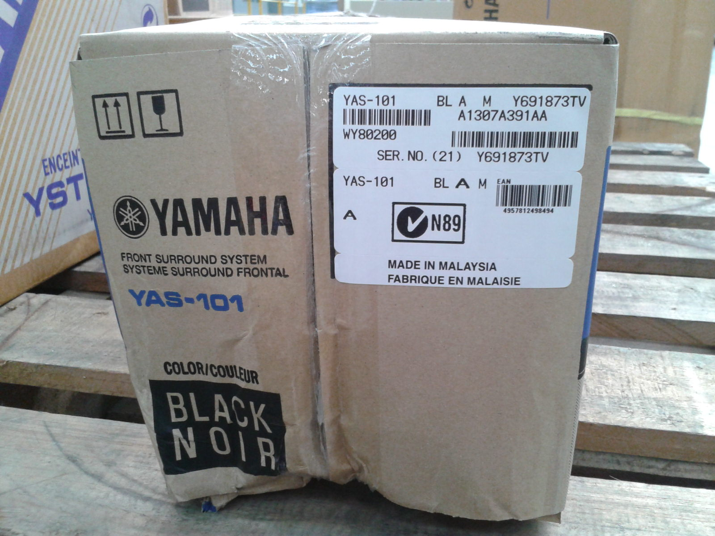

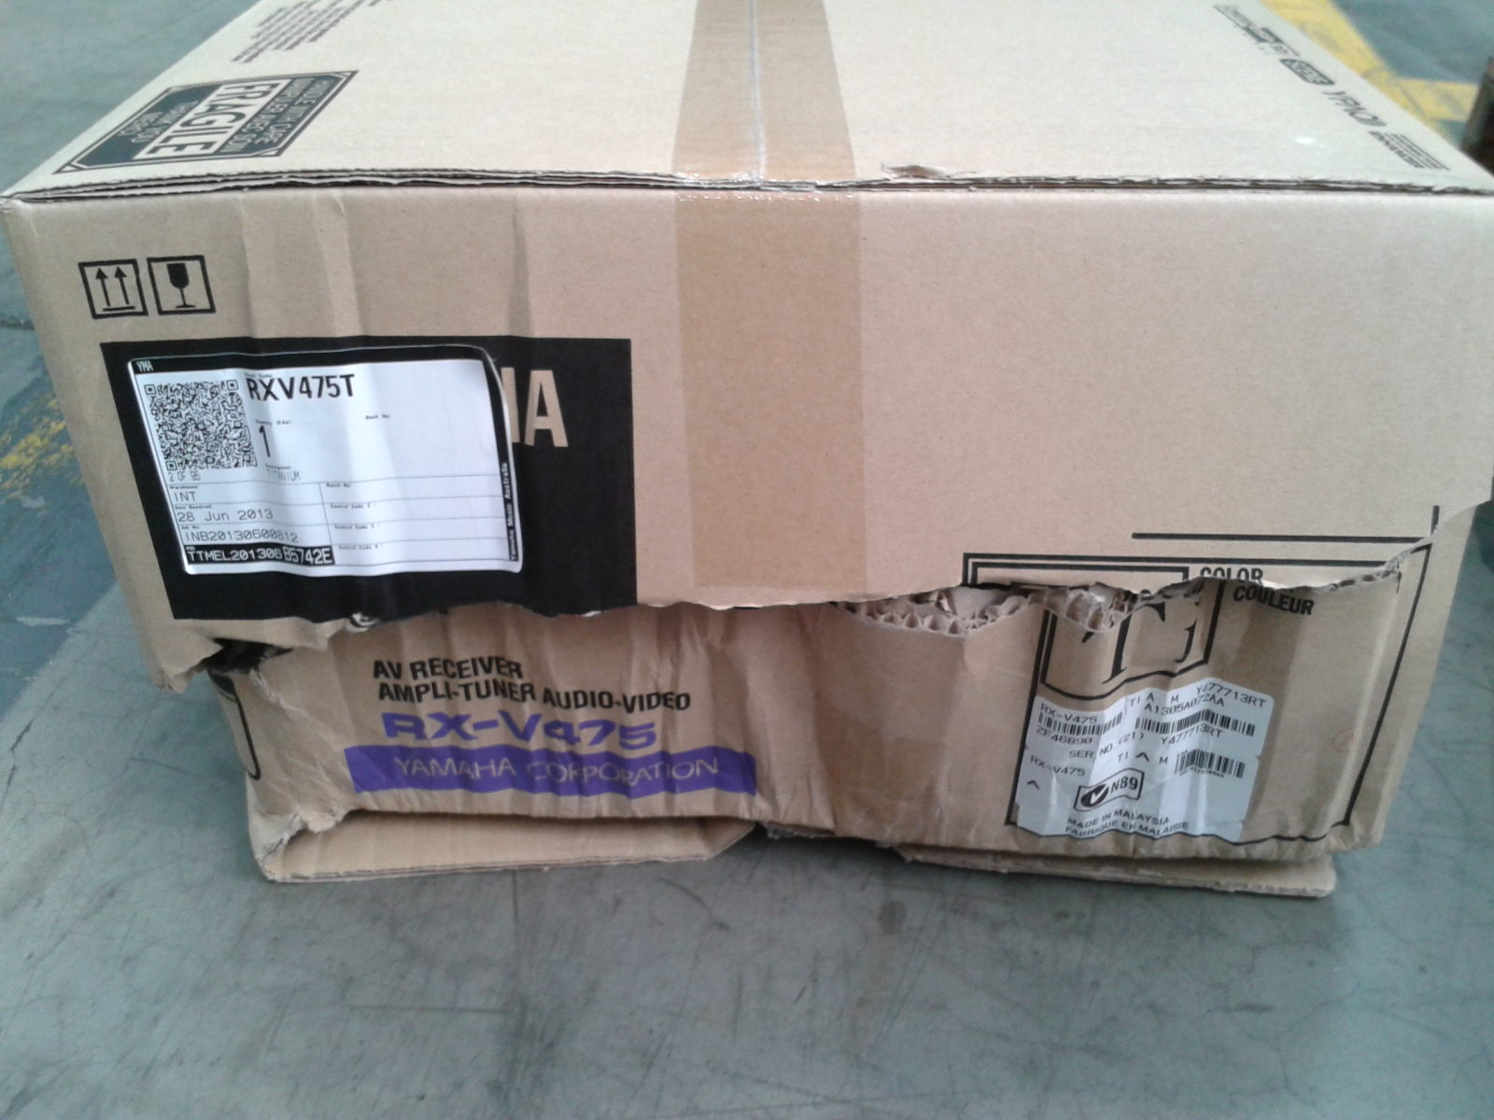

Reported by…Yovinus Sulastrie…………………………………….